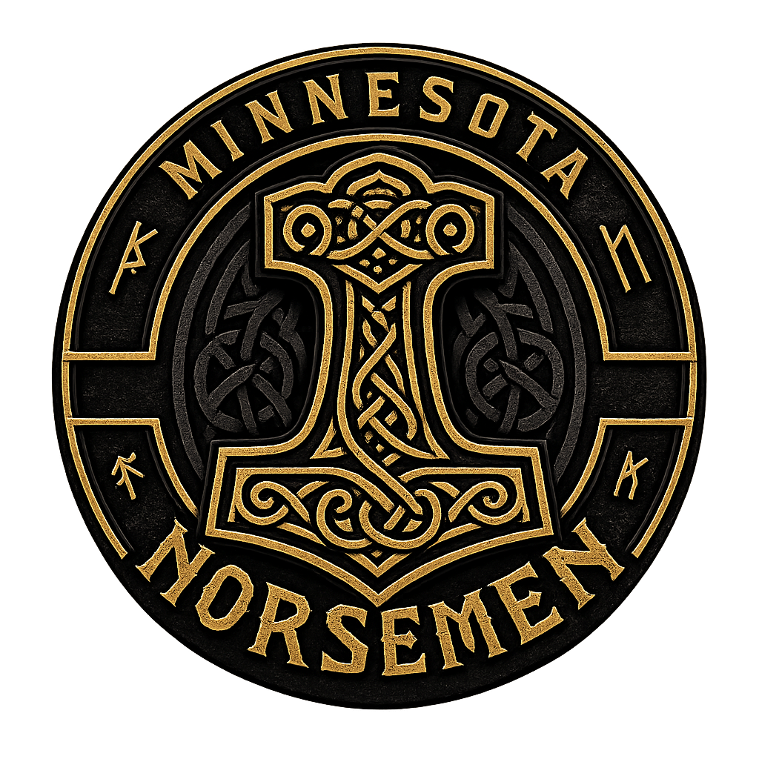 | 2027 SPONSORSHIP &  COMMUNITY PARTNERSHIP GUIDE  MORE THAN FOOTBALL. BUILDING BETTER MEN.  MINNESOTA 501(c)(3) NONPROFIT ORGANIZATION

WHO WE ARE
Minnesota Norsemen Football is a Minnesota 501(c)(3) nonprofit organization built to develop men of character through accountability, discipline, teamwork, and competition while representing our community with pride, respect, and integrity.
WHY PARTNER WITH THE NORSEMEN?
Your partnership helps us build a stable, family-friendly football organization while supporting the people, facilities, equipment, and community work that make the program possible. As a recognized 501(c)(3) nonprofit, eligible contributions may be tax-deductible to the extent permitted by law.

WHAT YOUR PARTNERSHIP SUPPORTS
⚒ Safe game-day facilities | ⚒ Practice field rentals
⚒ Player equipment and uniforms | ⚒ Team insurance and operating needs
⚒ Community service initiatives | ⚒ Youth football clinics and outreach
⚒ Family-friendly game-day experiences | ⚒ Leadership and player development

LEAVE IT BETTER THAN YOU FOUND IT.

 | 2027 PARTNERSHIP LEVELS  A starting point for businesses and organizations that want to grow with us.

WARRIOR PARTNER  $500 | • Website partner listing with logo and link  • Social media welcome / thank-you post  • Digital Norsemen Partner badge  • Sponsor appreciation recognition

SHIELD PARTNER  $1,000 | • Everything in Warrior  • Sponsor-provided field banner display  • Game-day public address acknowledgment  • 2 season passes  • Additional social media spotlight

LONGSHIP PARTNER  $2,500 | • Everything in Shield  • Featured website sponsor spotlight  • Enhanced game-day recognition  • Livestream acknowledgment, when available  • 4 season passes  • Invitation to select team and community events

JARL PARTNER  $5,000 | • Everything in Longship  • Premium banner placement  • Featured season-long recognition  • 6 season passes  • Community and event recognition  • Team appearance opportunity, subject to scheduling

FOUNDING PARTNER  $7,500 | • Everything in Jarl  • Premier Founding Partner designation  • Top-tier logo placement in sponsor materials  • 10 season passes  • Founding Partner plaque and recognition  • Permanent website recognition as an early supporter  • Custom partnership planning meeting  • Limited availability

Package benefits are subject to venue availability, league rules, scheduling, and other operational requirements. Banner production is the responsibility of the sponsor unless otherwise agreed.

MORE WAYS TO PARTNER
Not every partnership fits neatly into a tier. We can build one that makes sense for both sides.

HELMET SPONSOR  Recognition tied to team helmet assets and approved placements. | JERSEY SPONSOR  Recognition opportunities connected to approved uniform placements.
GAME DAY SPONSOR  Featured recognition around a selected Norsemen home game. | LIVESTREAM SPONSOR  Recognition connected to team livestream coverage, when available.
PLAYER OF THE GAME  Recognition attached to a featured postgame player honor. | COMMUNITY EVENT  Support outreach, youth clinics, service projects, or other community work.
EQUIPMENT SPONSOR  Help offset football equipment, uniforms, and operational needs. | TRAVEL SPONSOR  Help support transportation and road-game expenses.

LET'S BUILD SOMETHING TOGETHER
If you do not see a package that fits, reach out. We are happy to discuss a partnership that reflects your goals, your budget, and the needs of the Minnesota Norsemen while keeping the relationship consistent with our nonprofit mission.
1  CHOOSE  Select a tier or custom opportunity. | 2  CONNECT  Email or message the Norsemen. | 3  CONFIRM  Finalize support level and recognition. | 4  BUILD  Send your logo/assets and join us.

PARTNERSHIP CONTACT
minnesotanorsemenfootball@gmail.com
Or send a direct message to Minnesota Norsemen Football on social media.

501(c)(3) NOTICE
Minnesota Norsemen Football is a recognized 501(c)(3) nonprofit organization. Contributions may be tax-deductible to the extent permitted by law. The deductible portion of a payment may be reduced by the fair market value of tickets or other goods or services received. Sponsors should consult their tax advisor regarding their individual circumstances.

